Roger woodard – speaker, PRESENTER & LECTURER
M:07397192299
email:rogerwoodard@icloud.com
Twitter:RogerOB49
Linkedin
https://roger2018.wixsite.com/website
https://www.facebook.com/RogerOB49

The History of the UK Extractive Industry (How this has changed over time).‘Perception and Reality’ Why the Extractive Industry is so important to the UK Economy. Espeacially now after CV-19.

What is a Quarry? (This explains the how a quarry starts, produces to its restoration).

Life as a OHAS Officer (My experiences H&S, 'Oh Your’e One of Them'! This includes Accident investigations, Why people behave unsafely)

Investigating Major Accidents, Why its so important.

Piper Alpha, Lessons Learnt?

Bluewater Horizon Disaster, Profit over Caution?

The ‘Pennyvenie' Incident (Scottish Coal Major Accident)

The Fearless Elsie McGill - 'Queen of the Hurricanes’

“Micky” Martin - One of the Greatest Bomber Pilots

Angels in Olive Drab - Nurses Abroad in the 2nd World War.

A Soldiers 500 Day Odyssey (Untold Stories of the 2nd WW).

Leadership, Good & Bad

Europe and the Aftermath in 1945.

’The Battle for Moscow’.

The Untold Story of the Battle for ‘Smolensk, 1943’.

Most can also be presented over media platforms such as Zoom

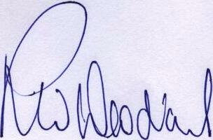
Sincerely Yours,

R W Woodard

